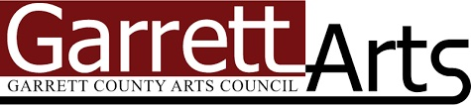
Final Report for Garrett County Arts Council’s
Community Arts Development Project Grants
Funding for public arts activities occurring between
April 1, 2026 - August 15, 2026

The Garrett County Arts Council, Inc. (GCAC) has been supporting the arts (visual arts, music, theatre, dance, literary arts and culinary arts) in Garrett County since 1976. GCAC was designated Garrett County's official arts agency by the Board of Garrett County Commissioners in 1993 for the receipt and disbursement of public grant funds administered by the Maryland State Arts Council to support visual arts, music, dance, theatre, literary arts, and culinary arts.

GCAC’s vision is for Garrett County to have a vibrant and sustainable arts community for artists, their audiences, and the community at large. The GCAC Board of Directors and staff are committed to aiding, encouraging, advising, and coordinating activities dedicated to the promotion of cultural arts in Garrett County, and to integrate such activities into the life of our community.

GCAC is committed to advancing and modeling equity, diversity, accessibility, and inclusion in all aspects of our programs and events, embracing equity and non-discrimination regardless of race, religious creed, color, age, gender expression, sexual orientation, class, language, and/or ability.

Garrett County Arts Council Community Arts Development Funding for Project Grant Awards is supported in part by Maryland State Arts Council (msac.org), Board of Garrett County Commissioners, and private gifts.
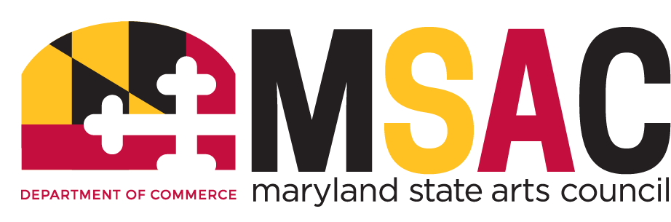
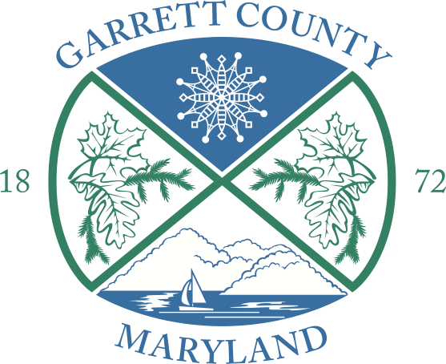
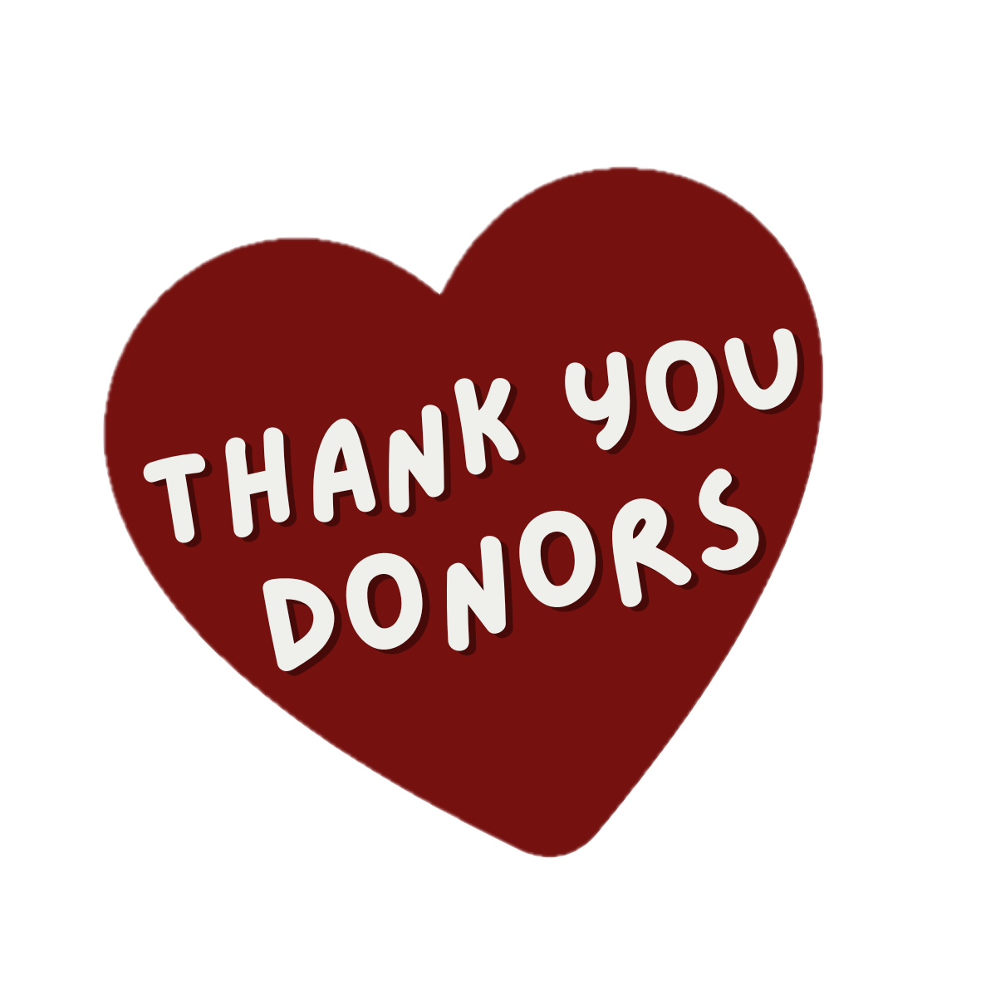

Thank you for your role in helping make Garrett County's arts community stronger.

Please submit this report within 30 days of project completion, and no later than August 15, 2026.

Before You Begin
This report is your opportunity to tell us how your project went. We know that every project changes as it comes to life, so don't worry if everything didn't go exactly as planned. We're interested in hearing what you accomplished, what you learned, and the impact your project had on our community.
We appreciate your time and attention in providing us information on what your funds were used for. There is no word count requirement in the narrative questions; however, we encourage you to provide a complete and thoughtful response so staff and reviewers can gain a full understanding of your project, its goals, and its potential impact. Your reports help us to make our own reports to the state for funding and support stronger every year.

About You
Independent Artist / Organization Name:
Project Name:
Primary Contact:
Title:
Email:
Phone:
Website:
Grant Award Amount:
Project Dates:

Project at a Glance
Was your project completed as originally proposed?
☐ Yes ☐ Mostly (Please explain.) ☐ No (Please explain.)

If your project changed along the way, tell us what changed and why.
Projects evolve! We'd love to hear about any unexpected challenges, opportunities, scheduling changes, or creative discoveries that shaped your project. If answering “no,” did you notify GCAC staff for change approvals as indicated in your grant letter of agreement?

Tell Us About Your Project
What activities took place during the grant period?
What did you create, present, organize, or accomplish?

What are you most proud of?
Tell us about a success, favorite moment, or something that exceeded expectations.

Project by the Numbers
These answers are required for GCAC to enter into our Community Arts Development Grant Report to the Maryland State Arts Council. The numbers help GCAC demonstrate to state and federal funding agencies the impact of grant funding and secure future support for local artists and organizations. If a question doesn't apply, simply enter N/A or 0.
Number of Events or Activities:
Number of Artists Participating:
Number of Volunteers:
Full-Time Staff:
Part-Time Staff:
Total Attendance:
Free Attendees:
Paid Attendees:
Youth Participants (18 and under):
Virtual Participants:
Average Ticket Price (if applicable):
Estimated Garrett County Residents Served:
Estimated Visitors from Outside Garrett County:

Community Impact
Who did this project reach? Who participated? Who attended? What communities were engaged?

What impact did this project have on your community? Please share any stories, observations, or examples that help illustrate the value of your project. Testimonials are always welcome.

Evaluation
What worked especially well?

What challenges did you encounter? How did you adapt or solve them?

If you were to do this project again, what would you change?

What's next? Will this project continue? Did it lead to new partnerships, ideas, or future opportunities?

Accessibility
How did you help make this project welcoming and accessible? (Indicate all that apply.)
☐ Accessible venue
☐ ADA accommodations available
☐ Free admission
☐ Sliding-scale admission
☐ Accessibility contact available
☐ Other
Please describe any accessibility efforts you made.

Acknowledgement
How did you acknowledge support from the Garrett County Arts Council and the Maryland State Arts Council?
Please attach examples with this report.

Budget
Please complete and attach the FY26 Final Budget Report spreadsheet.

Project Highlights (Optional, but Encouraged!)
Help us celebrate your work! You're welcome to include photos, press coverage, social media posts, testimonials, participant feedback, videos, or anything else you'd like to share.

Anything Else?
Is there anything else you'd like us to know? We'd love to hear about unexpected successes, memorable moments, or anything else that helps tell the story of your project.

Final Submission Checklist
Before submitting your Final Report, please make sure you have completed the following:
☐ Completed all sections of the Final Report narrative.
☐ Completed and attached the FY26 Final Budget Report Template.
☐ Attached documentation supporting grant-funded expenses (receipts, invoices, proof of payment, or other financial records).
☐ Attached proof of funding acknowledgment for the Garrett County Arts Council and the Maryland State Arts Council (examples may include programs, flyers, posters, press releases, website screenshots, social media posts, event signage, or other promotional materials).
☐ Attached any additional supporting materials you would like to share (optional), such as photographs, press coverage, participant or audience testimonials, participant feedback or evaluations, marketing materials, videos, or any other project documentation.
- If your project received media coverage, attached copies or provided links (optional).

Certification
I have reviewed my report and certify that all information provided is complete and accurate to the best of my knowledge.
By signing below, the applicant confirms that all grant funds were used in accordance with the Garrett County Arts Council Community Arts Development Project Grant Guidelines and Grant Agreement.
Name:
Title:
Organization (if applicable):
Date:
Electronic Signature:

Thank you for sharing your project with us!
Your report helps the Garrett County Arts Council demonstrate the impact of public arts funding, celebrate the accomplishments of our grantees, and strengthen future funding opportunities for artists, organizations, schools, and communities throughout Garrett County.

